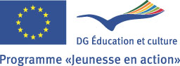

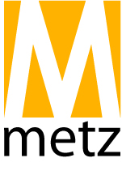
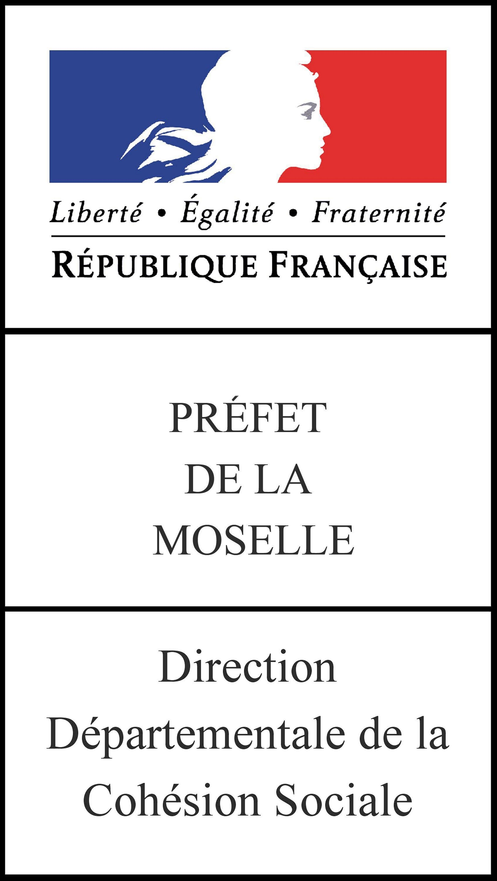
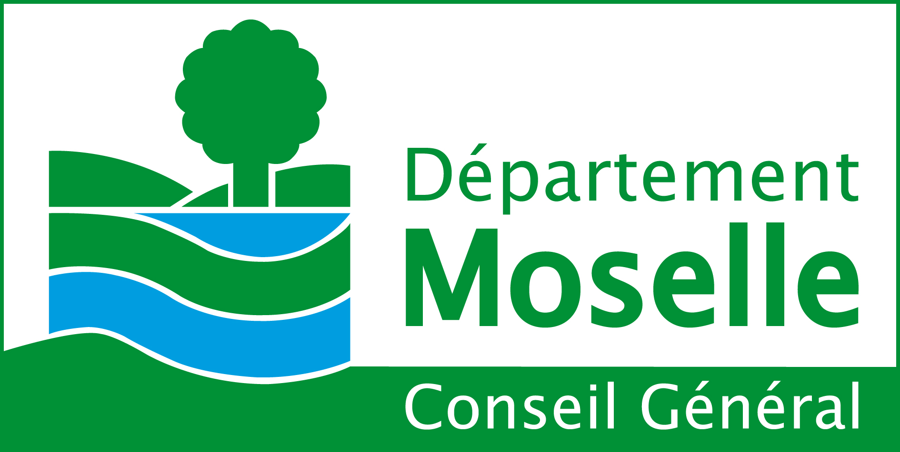
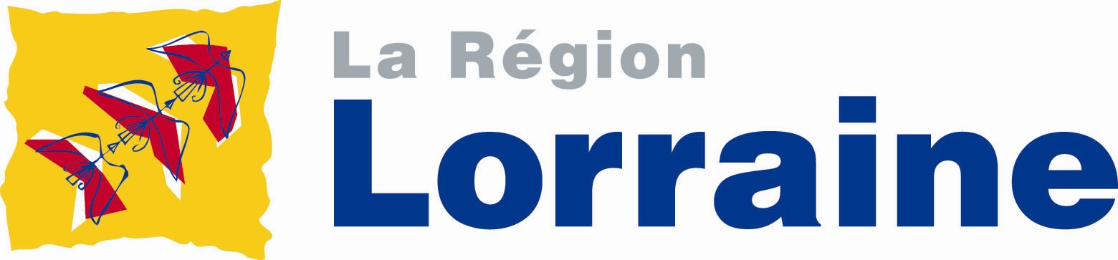
10-10 | 11-10 | 12-10 | 13-10 | 14-10 | 15-10 | 16-10 | 17-10 | 18-10
 | Breakfast | Breakfast | Breakfast | Breakfast | Breakfast | Breakfast | Breakfast | Breakfast
 | Name games, getting-to-know, presentation of programme | Every-day evaluation | Every-day evaluation | Every-day evaluation | Every-day evaluation | Every-day evaluation | Every-day evaluation | General clearing
Arrival of participants | Lunch | Team sport workshop | Workshop – doping in sport | Workshop – Sport and environment, human rights | Trip to Metz city centre (packed lunch) | Sport event with local community | Team sport workshop | Final meeting and good-bye
Walk around the place of accomodation | Presentation of countries, NGOs, Youth in Action | Lunch | Lunch | Lunch | Packed lunch | Lunch | Lunch | Departure of participants
Introduction | Youth Pass presentation  Reflexion Groups | Workshop – „Sport in your country“ | Workshop – Olympic games | Untypical sports – team activities | Visit of town hall  Meeting with sportsmen | Open Space- Future projects | Final Evaluation, Youthpass
Dinner | Youth Pass presentation  Reflexion Groups | Reflexion groups | Reflexion groups | Reflexion  groups | Reflection groups in the city | Reflexion groups | Reflexion groups
Game evening | Intercultural Dinner | Dinner | Dinner | Dinner | Dinner | Dinner | Dinner
 |  | International evening | International evening | Internationa evening | International evening | International evening | International evening

